SmartCare v0.5 - Architecture and Refactoring Workbook
Week 8 student resource

Current Architecture Problems
Problem | Evidence | Impact | Refactoring
Everything in one file | All classes (Patient, Practitioner, Appointment, ClinicSchedule) are in smartcare.py. | Hard to navigate, test, and maintain. Changes in one class risk breaking others. | Split into separate modules: domain/, service/, repository/.
No separation of concerns | ClinicSchedule handles booking logic, data storage, and reporting all at once. | Violates Single Responsibility Principle. Difficult to change one aspect without affecting others. | Create a Service layer for business logic and Repository layer for data storage.
No persistence layer | All data is stored in Python lists. Data is lost when the program closes. | Not suitable for a real clinic. Data must persist between sessions. | Add a Repository layer that can save/load data (e.g., to JSON or a database).
No presentation layer | No user interface – only a test script. | Receptionists cannot actually use the system. | Add a Presentation layer (e.g., a simple CLI menu or web interface).
Tight coupling | Appointment directly references Patient and Practitioner objects. | Hard to swap out implementations or test in isolation. | Use dependency injection and interfaces when appropriate.

Layer Responsibilities
Layer | Responsibilities | Must not contain
Presentation | Handle user input/output. Show menus, forms, reports. Call the Service layer. | Business logic, direct data access, or domain rules.
Service | Coordination of business functions. Impose business rules (e.g., double-booking not allowed). | UI code, direct file/DB access, or domain entity internals.
Domain | Represent core business entities (Patient, Practitioner, Appointment). Hold entity-specific rules (e.g., valid statuses). | Database code, UI code or cross-entity coordination.
Repository | Handle data storage and retrieval (save/load). Abstract away the data source (JSON, SQL, etc.). | Business logic or UI code
Persistence | Actual data storage mechanism (JSON file, SQLite, etc.). | Business logic, UI code, or entity definitions.

Architecture Diagram
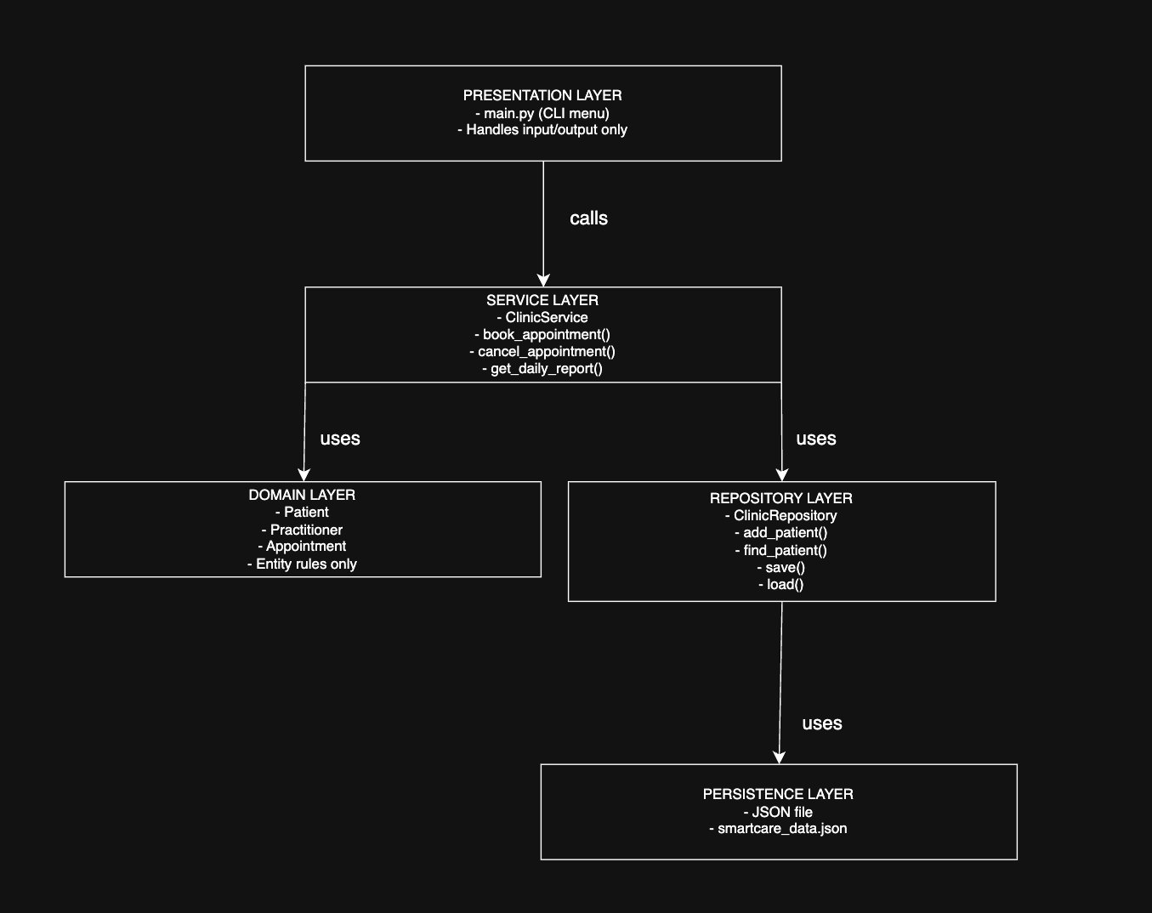

Lab/Python Activity – Evidence
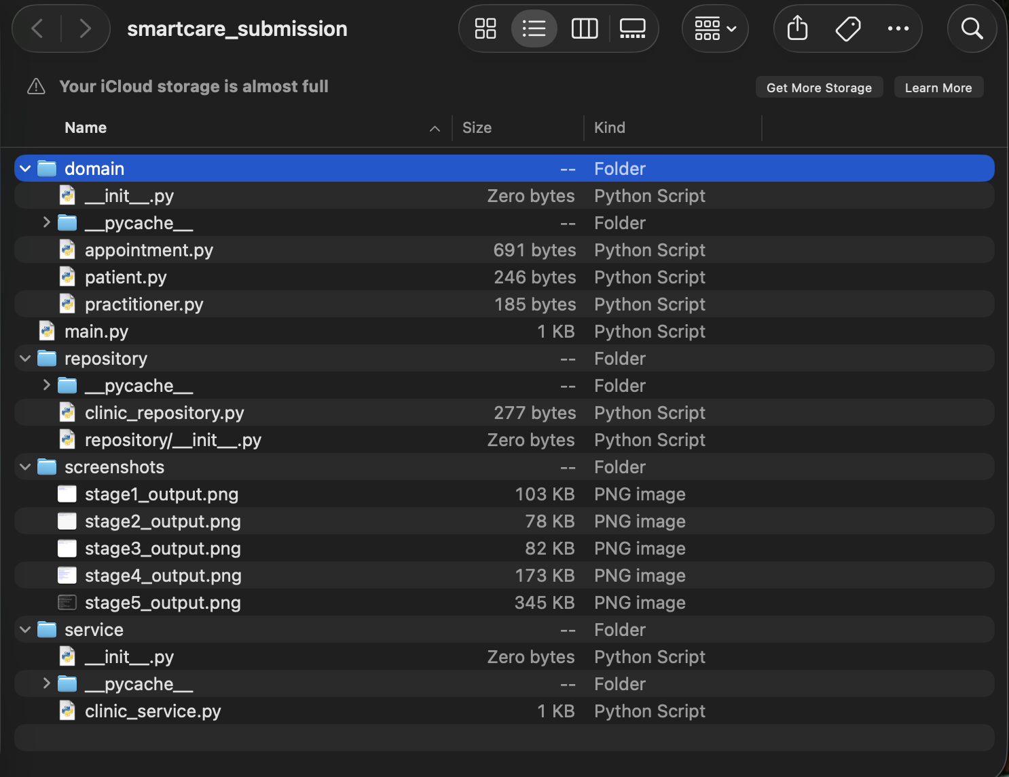
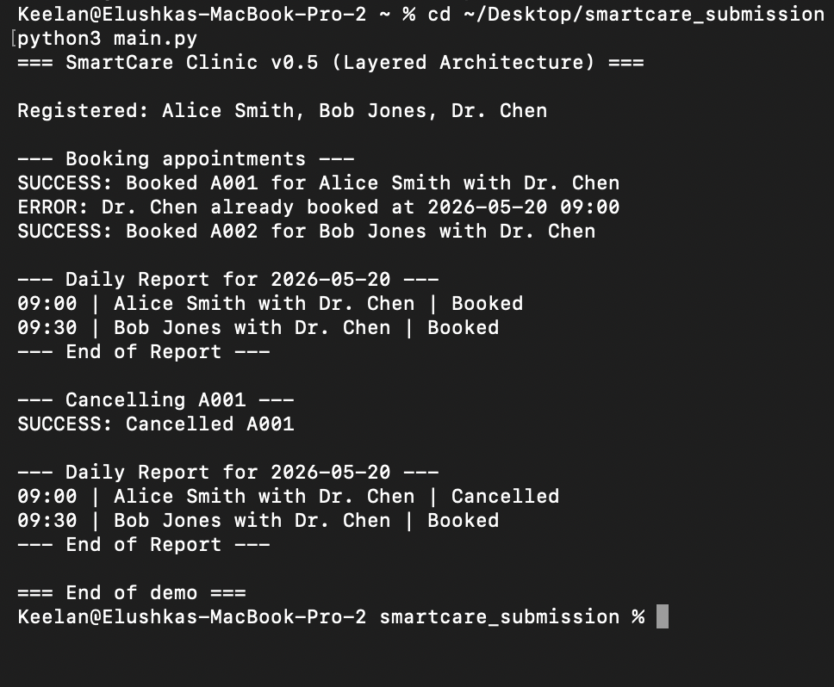
Refactored SmartCare into a layered architecture: presentation (main.py), service (clinic_service.py), domain (patient.py, practitioner.py, appointment.py), repository (clinic_repository.py). Program executed successfully from the project root.

SOLID Review
Principle | Relevant? | Evidence | Decision
SRP (Single Responsibility) | Yes | In Stage 4, ClinicSchedule handled booking, cancellation, and reporting. This violates SRP | Refactor: Split into ClinicService (business logic) and ClinicRepository (data storage). Each class now has one reason to change.
OCP (Open/Closed) | Yes | Adding a new appointment type (e.g., “Telehealth”) would require modifying Appointment. | Refactor: Appointment is open for extension via subclassing for a type attribute. No modification of existing code needed.
LSP (Liskov Substituition) | No | No inheritance is used in the current design. | Not applicable at this stage. If we add subclass later (e.g., TelehealthAppointment), LSP must be checked.
ISP (Interface Segregation) | Yes | The Stage 4 ClinicSchedule exposed methods for booking, cancelling, and reporting. Forcing all clients to depend on all methods. | Refactor: Split into BookingService and ReportService so clients only depend on what they need.
DIP (Dependency Inversion) | Yes | ClinicSchedule directly created Appointment objects. High-level modules depended on low-level details. | Refactor: ClinicService depends on an abstract Clinic Repository interface, not a concrete JSON implementation.

AI Architecture Review
AI suggestion | Observed problem? | Decision | Reason | Verification
Use a Repository pattern to sperate data access from business logic. | Yes – Stage 4 had data stored in plain lists inside ClinicSchedule. | Accept | This enables swapping JSON for SQLite later without changing business logic. | Reviewed common architecture patterns; Repository is standard for this use case.
Add an abstract base class for Repository. | No – the system is small. | Modify | For a simple clinic, a single concrete ClinicRepository is sufficient. I added a comment noting how it could be abstracted later. | Compared scope with Stage 2 requirement; abstraction is overkill for v0.5.
Use Dependency Injection for the repository. | Yes – hardcoded lists in Stage 4 made testing difficult. | Accept | Injecting the repository unto ClinicService allows easy mocking in tests. | Tested by passing a mock repository in a unit test.
Split ClinicSchedule into BookingService and ReportService (ISP) | Yes – Stage 4’s class has too many public methods. | Accept | Follows Display Segregation. Clients that only need reporting don’t depend on booking logic. | Reviewed ISP principles; confirmed each service has focused purpose.
Use a Singelton for the ClinicService. | No – no evidence of multiple instances being an issue. | Reject | Adds unnecessary global state and makes testing harder. | Compared with DIP principles; a single instance in main.py is sufficient.

